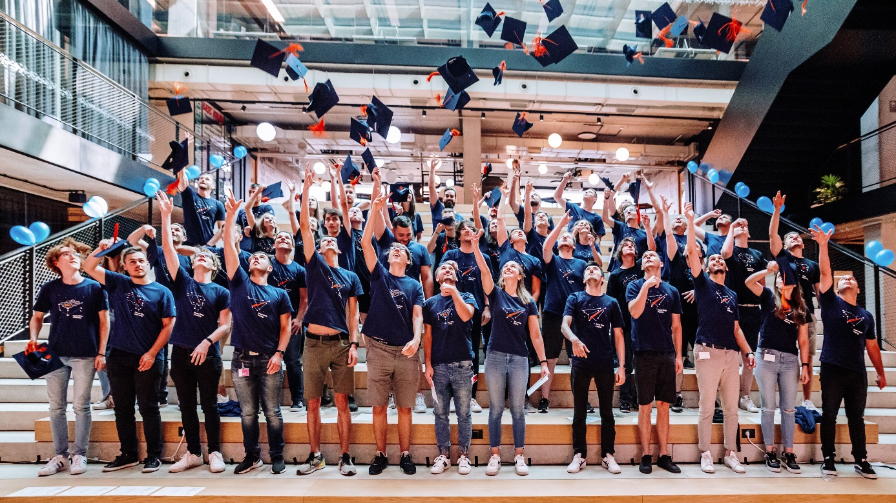
INFOBIP BUSINESS INTERNSHIP
Dear students,
We are pleased to announce the Business edition of internship programs organized by Infobip in 2023. Apart from the fact that you will be able to acquire theoretical and practical knowledge with the support of mentors from various fields, after completing the program, there is a possibility of employment in a global IT company.
Gain practical experience. Learn from experienced mentors. Create the first step towards a career in data and analytics. Never stop playing.
Who is Infobip?
At Infobip, we value creativity, persistence, and innovation. Since 2006, we have been innovating at the edge of technological possibilities and are now shaping global communications of the future. With a communications platform that reaches 7+ billion transactions monthly and 4+ billion devices worldwide, we ensure you can connect with your favorite brands through your preferred channels.
If you are a student of graduate studies or final year of undergraduate studies in the field of business and/or IT, looking to gain practical experience in a real global IT company standing behind a solution that reaches 70% of Earth's population, join our internship program and get a chance to land your first job at Infobip!
What's in it for you?
- Possibility to land your first job – Every intern that is selected for the program will have a chance to get a job offer at the end of the internship, based on progress and evaluation during the program.
- Paid internship – Our internship is a paid program.
- Cutting-edge technology & processes
- Learn as you grow – You will learn through practical work on your project and get continuous feedback from your mentors, helping you improve and progress.
- More Infobip perks if you join us after the internship – IT equipment, welcome goodie bag, structured onboarding, a team taking care of all the equipment/support you need, company team buildings and other organized activities, the company library, access to the world leading MOOC (Massive Open Online Course) platform Udemy as well as multitude of both internal and external learning materials, organized sports, free lunch at our campuses and offices...
About program:
Below you can read basic information about each program and application. Also, we kindly recommend a visit to our Internship web page.
Roles:
- Compliance Intern
- Revenue Intern
- Operations Intern
- Finance Intern
- POP Intern
- Customer Success Intern
- Corporate Social Responsibility (CSR) Intern
- Customer Support Intern
- Integration Services Intern
- Customer Experience Intern
- Product Success Intern

All undergraduate final-year students and graduate students looking for a first working experience can apply. The duration can be from 3 months to 12 months based on the program.
The program will start on the 9th of October and applications will be open until we find suitable candidates.

“An egoless and humble mentality, the idea that we're just starting, the thought of being crazy artists who learn by doing - that's the culture we’ve built together.”

Silvio Kutic
CEO

We are looking forward to meeting you!

